**ASSIGNMENT-3**

Q1. Definition of Cloud Computing

Cloud Computing is defined as storing and accessing of data and computing services over the internet. It doesn’t store any data on your personal computer. It is the on-demand availability of computer services like servers, data storage, networking, databases, etc. The main purpose of cloud computing is to give access to data centers to many users. Users can also access data from a remote server.  
Examples of Cloud Computing Services: AWS, Azure, Google

Q2. Compare Hybrid vs Public vs Private

* The public cloud refers to the cloud computing model in which IT services are delivered via the internet. As the most popular model of cloud computing services, the public cloud offers vast choices in terms of solutions and computing resources to address the growing needs of organizations of all sizes and verticals. The defining features of a public cloud solution include: High elasticity and scalability and A low-cost subscription-based pricing tier. Services on the public cloud may be free, freemium, or subscription-based, wherein you’re charged based on the computing resources you consume. The computing functionality may range from common services—email, apps, and storage—to the enterprise-grade OS platform or infrastructure environments used for [software development and testing](https://www.bmc.com/blogs/sdlc-software-development-lifecycle/). The cloud vendor is responsible for developing, managing, and maintaining the pool of computing resources shared between multiple tenants from across the network.
* The private cloud refers to any cloud solution dedicated for use by a single organization. In the private cloud, you’re not sharing cloud computing resources with any other organization. The data centre resources may be located on-premise or operated by a third-party vendor off-site. The computing resources are isolated and delivered via a secure private network, and not shared with other customers. Private cloud is customizable to meet the unique business and security needs of the organization. With greater visibility and control into the infrastructure, organizations can operate compliance-sensitive IT workloads without compromising on the security and performance previously only achieved with dedicated on-premise data centres.
* The hybrid cloud is any cloud infrastructure environment that combines both public and private cloud solutions. The resources are typically orchestrated as an integrated infrastructure environment. Apps and data workloads can share the resources between public and private cloud deployment based on organizational business and technical policies around aspects like: Security, Performance, Scalability, Cost, Efficiency. This is a common example of hybrid cloud: Organizations can use private cloud environments for their IT workloads and complement the infrastructure with public cloud resources to accommodate occasional spikes in network traffic.

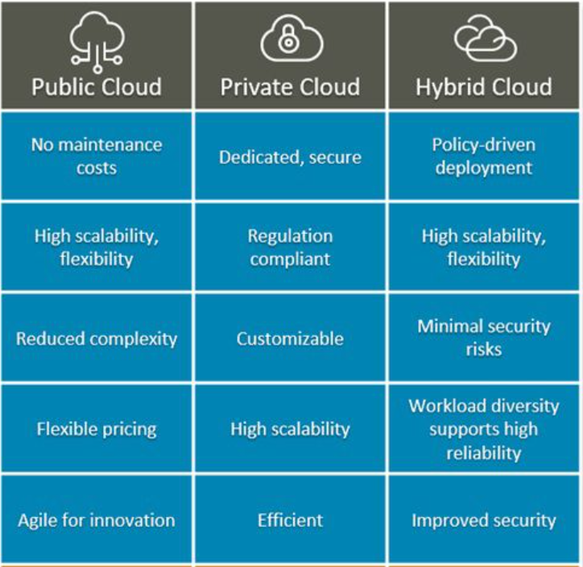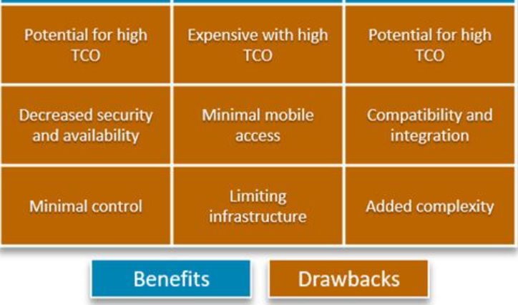

Q3. Challenges of Cloud Computing

1. SECURITY: The topmost concern in investing in cloud services is security issues in cloud computing. It is because your data gets stored and processed by a third-party vendor and you cannot see it. Every day or the other, you get informed about broken authentication, compromised credentials, account hacking, data breaches, etc. in a particular organization. It makes you a little more sceptical. Fortunately, the cloud providers, these days have started to put efforts to improve security capabilities. You can be cautious as well by verifying if the provider implements a safe user identity management system and access control procedures. Also, ensure it implements database security and privacy protocols.

2. PASSWORD SECURITY: As large numbers of people access your cloud account, it becomes vulnerable. Anybody who knows your password or hacks into your cloud will be able to access your confidential information. Here the organization should use a multiple level authentication and ensure that the passwords remain protected. Also, the passwords should be modified regularly, especially when a particular employee resigns and leave the organization. Access rights to usernames and passwords should be given judiciously.

3. COST MANAGEMENT: Cloud computing enables you to access application software over a fast internet connection and lets you save on investing in costly computer hardware, software, management and maintenance. This makes it affordable. But what is challenging and expensive is tuning the organization’s needs on the third-party platform. Another costly affair is the cost of transferring data to a public cloud, especially for a small business or project.

4. LACK OF EXPERTISE: With the increasing workload on cloud technologies and continuously improving cloud tools, the management has become difficult. There has been a consistent demand for a trained workforce who can deal with cloud computing tools and services. Hence, firms need to train their IT staff to minimize this challenge.

5. INTERNET CONNECTIVITY: The cloud services are dependent on a high-speed internet connection. So the businesses that are relatively small and face connectivity issues should ideally first invest in a good internet connection so that no downtime happens. It is because internet downtime might incur vast business losses.

6. CONTROL OR GOVERNANCE: Another ethical issue in cloud computing is maintaining proper control over asset management and maintenance. There should be a dedicated team to ensure that the assets used to implement cloud services are used according to agreed policies and dedicated procedures. There should be proper maintenance and that the assets are used to meet your organization’s goals successfully.

7. COMPLIANCE: Another major risk of cloud computing is maintaining compliance. By compliance we mean, a set of rules about what data is allowed to be moved and what should be kept in-house to maintain compliance. The organizations must follow and respect the compliance rules set by various government bodies.

8. MULTIPLE CLOUD MANAGEMENT: Companies have started to invest in multiple public clouds, multiple private clouds or a combination of both called the hybrid cloud. This has grown rapidly in recent times. So it has become important to list challenges faced by such organizations and find solutions to grow with the trend.

9. CREATING A PRIVATE CLOUD: Implementing an internal cloud is advantageous. This is because all the data remains secure in-house. But the challenge here is that the IT team has to build and fix everything by themselves. Also, the team needs to ensure smooth functioning of the cloud. They need to automate maximum manual tasks. The execution of tasks should be in the correct order. So, at the moment, it sounds quite difficult to set up a private cloud all by yourself. But many organizations are planning to do so in future.

10. PERFORMANCE: When your business applications move to a cloud or a third party vendor, so your business performance starts to depend on your provider as well. Another major problem in cloud computing is investing in the right cloud service provider. Before investment, you should look for providers with innovatory technologies. The performance of the BI’s and other cloud-based systems are linked to the provider’s systems as well. Be cautious about choosing the provider and investigate that they have protocols to mitigate issues that arise in real-time.

11. MIGRATION: Migration is nothing but moving a new application or an existing application to a cloud. In the case of a new application, the process is pretty straightforward. But if it is an age-old company application, it becomes tedious. Velostrata conducted a survey recently, wherein 95% of organizations are moving their applications to the cloud. The survey showed that most organizations are finding it a nightmare. Some notable issues faced here are slow data migrations, security challenges in cloud computing, extensive troubleshooting, application downtime, migration agents, and cutover complexity.

12. INTEROPERABILITY AND PORTABILITY: Another challenge of cloud computing is that applications need to be easily migrated between cloud providers without being locked for a set period. There is a lack of flexibility in moving from one cloud provider to another because of the complexity involved. Changing cloud inventions bring a slew of new challenges like managing data movement and establishing a secure network from scratch. Another challenge is that customers can’t access it from everywhere, but this can be fixed by the cloud provider so that the customer can securely access the cloud from anywhere.

13. RELIABILITY AND HIGH AVAILABILITY: Some of the most pressing issues in cloud computing is the need for high availability (HA) and reliability. Reliability refers to the likelihood that a system will be up and running at any given point in time, whereas availability refers to how likely it is that the system will be up and running at any given point in time. Because most businesses are now reliant on third-party services, cloud systems must be dependable and robust. Cloud providers continue to lack round-the-clock service, resulting in frequent outages. It is critical to use internal or third-party tools to monitor the service being provided. It is critical to have plans in place to monitor SLAs, usage, robustness, performance, and business reliance on these services.

14. HYBRID-CLOUD COMPLEXITY: For any company, a hybrid cloud environment is often a messy mix of multiple cloud application development and cloud service providers, as well as private and public clouds, all operating at once. A common user interface, consistent data, and analytical benefits for businesses are all missing from these complex cloud ecosystems. Cloud computing challenges such as scalability, integration, and disaster recovery are magnified in a hybrid cloud environment.

Q4. Compare IaaS, PaaS & SaaS

1. IAAS: Infrastructure As A Service (IAAS) is means of delivering computing infrastructure as on-demand services. It is one of the three fundamental cloud service model servers storage network operating system. In the user purchasing servers, software data center space, or network equipment and rent those resources as a fully outsourced service can demand model. It allows dynamic scaling and the resources are distributed as a service. It generally includes multiple-user on a single piece of hardware.

2. PAAS: Platform As A Service (PAAS) is a cloud delivery model for applications composed of services managed by a third party. It provides elastic scaling of your application which allows developers to build applications and services over the internet and the deployment models include public, private and hybrid.

3. SAAS**:** Software As A Service (SAAS) allows users to run existing online applications and it is a model software that is deployed as a hosting service and is accessed over Output Rephrased/Re-written Text the internet or software delivery model during which software and its associated data are hosted centrally and accessed using their client, usually an online browser over the web. SAAS services are used for the development and deployment of modern applications.  
Difference between IAAS, PAAS and SAAS:  
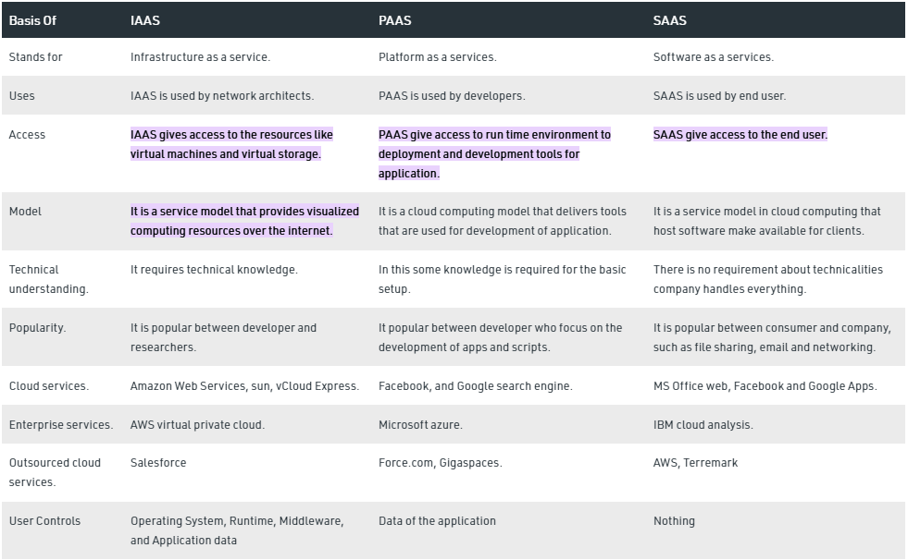

Q5. Benefits of Cloud Computing

1) Back-up and restore data: Once the data is stored in the cloud, it is easier to get back-up and restore that data using the cloud.

2) Improved collaboration: Cloud applications improve collaboration by allowing groups of people to quickly and easily share information in the cloud via shared storage.

3) Excellent accessibility: Cloud allows us to quickly and easily access store information anywhere, anytime in the whole world, using an internet connection. An internet cloud infrastructure increases organization productivity and efficiency by ensuring that our data is always accessible.

4) Low maintenance cost: Cloud computing reduces both hardware and software maintenance costs for organizations.

5) Mobility: Cloud computing allows us to easily access all cloud data via mobile.

6) IServices in the pay-per-use model: Cloud computing offers Application Programming Interfaces (APIs) to the users for access services on the cloud and pays the charges as per the usage of service.

7) Unlimited storage capacity: Cloud offers us a huge amount of storing capacity for storing our important data such as documents, images, audio, video, etc. in one place.

8) Data security: Data security is one of the biggest advantages of cloud computing. Cloud offers many advanced features related to security and ensures that data is securely stored and handled.

**Submitted By: Amogh Garg  
2020UCO1688  
COE-3**